## https://ds04.infourok.ru/uploads/ex/107a/000121e9-ea9fdfbd/img7.jpg

## Задание1. Составьте предложения в the Present Perfect Continuous Tense.

1. I/to read/this book/for three days.
2. We/to play volleyball/ for twenty minutes.
3. She/to clean/the flat/for more than an hour.
4. Peter/to swim/for half an hour.
5. Anna/to speak/on the phone/for an hour now.
6. You/to wait/for a bus/for ten minutes only.
7. Nelly and Mary/to do the shopping/since early morning.
8. It/to snow/since last night.
9. Jack and his friend/ to ride bikes/for three hours now.
10. The teacher/to explain/ a grammar rule/since the beginning of the lesson.

**Задание 2.Поставьте глаголы в скобках в правильную форму.**

1. Kevin … (to fish) since early morning.
2. Kim … (not to pack) her things for so long.
3. You … (to iron) clothes all day.
4. Allan … (not to wear) this jacket for three years.
5. I … (not to walk) a dog since four o’clock.
6. Monica and Sue …(to paint) the walls of the house since ten o’clock in the morning.
7. Mr May … (to read) this article for more than half an hour now.
8. It … (not to rain) since afternoon.
9. My neighbours … (to make) a noise since seven o’clock in the morning.
10. Brad … (fo try) to catch a taxi for fifteen minutes now.

|  |
| --- |
| **1. Подлежащее + 2. has/have + 3. been + 4. participle I + 5. др. члены предложения** |

* *He (1) has (2) been (3) translating (4) this article since yesterday (5) – Он переводит эту статью со вчерашнего дня.*

**Задание 3**Поставь глагол в скобках в Present Perfect или Present Perfect Continuous.

1. I (not to see) him for ages.
2. He (to do) his lessons since lunch.
3. I (not to hear) about him for a long time.
4. I (to drive) since I was 17.
5. Jack (to fail) his driving test three times because к doesn't know how to park.
6. I think he (make) a lot of improvement.
7. Alice (not/pass) her driving test because she doesn’t know the rules well.
8. She (worry) about this for two months.
9. She (study) the driver’s manual for hours every day.
10. She (not/take) another test yet.
11. I (to have) a headache since I got up.
12. He is my friend, I (to know) him for a long time.
13. Ivan has a stomachacke. He (to eat) junk food all day.
14. I (never to hear) that song before.

**Задание4. Составь предложения употребив**  Present Perfect или Present Perfect Continuous.

Пример:

She/clean/the flat for four hours. – She has been cleaning the flat for four hours.

1. I / read/Tolstoy stories/ in the park for two hours.
2. I /read/three stories.
3. Granny/knit/in the living room/ since morning.
4. Helen/travel/round Europe/for 3 weeks.
5. She/visit/already/3 countries.

**Задание5.**. Используйте Present Perfect или Present Perfect Continuous в вопросительных предложениях.

1. Your shirt smells terrible! … (you/smoke)? (Твоя рубашка ужасно пахнет! Ты курил?)
2. How long … (you/wait) for them? (Как долго ты их ждешь?)
3. How many glasses of beer … (he/drink) today? (Сколько бокалов пива он сегодня выпил?)
4. … (you/ever/live) in a tent? (Ты когда-нибудь жил в палатке?)
5. Where … (you/be)? (Где ты был?)
6. How much money … (Kevin/spend) in the casino? (Сколько денег потратил Кевин в казино?)
7. … (those vegetables/boil) since 2 o’clock? (Те овощи варятся с двух часов?)
8. … (you/defrost) the fridge yet? (Ты еще не разморозила холодильник?)
9. How many messages … (she/send) today? (Сколько сообщений она послала сегодня?)
10. How long … (your sister/travel)? (Как долго твоя сестра путешествует?)
11. How many people … (Angela/invite) to her party? (Сколько людей пригласила Анджела на свою вечеринку?)
12. … (you/sit) here for a long time? (Ты долго тут сидишь?)

**Задание6**Найдите в диалоге ошибки во временах глагола.

- Hello, Charles. I didn’t see you since yesterday morning. Where have you been?

- Actually I work on my first novel.

- I see. How long have you written it?

- For three weeks already. I have made a lot of interesting characters. I’ve been so busy today. You know I didn’t have a single cup of coffee since morning.

- And how many chapters have you been writing so far?

- 3 chapters are ready! And I have thought already of a nice title. But I didn’t decide yet what happens next.

- Well. Good luck to you!

**Задание7**

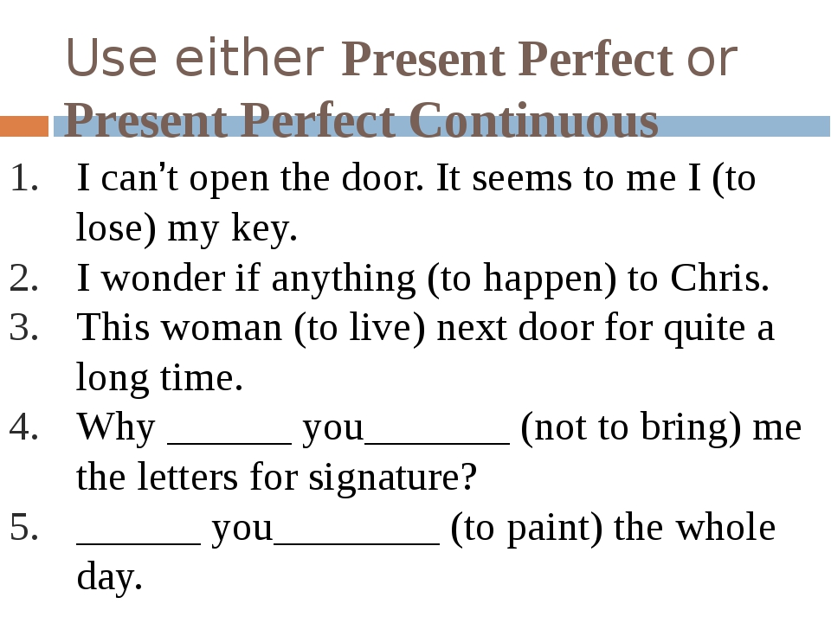

**Задание8**

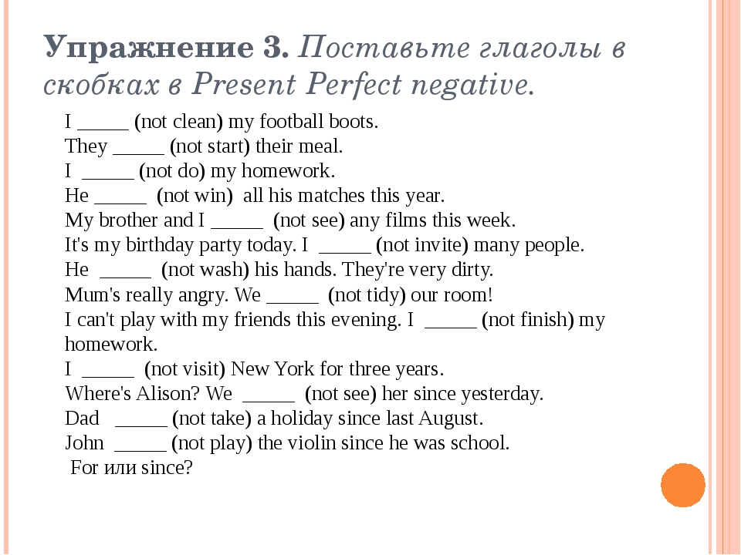

**Задание9**

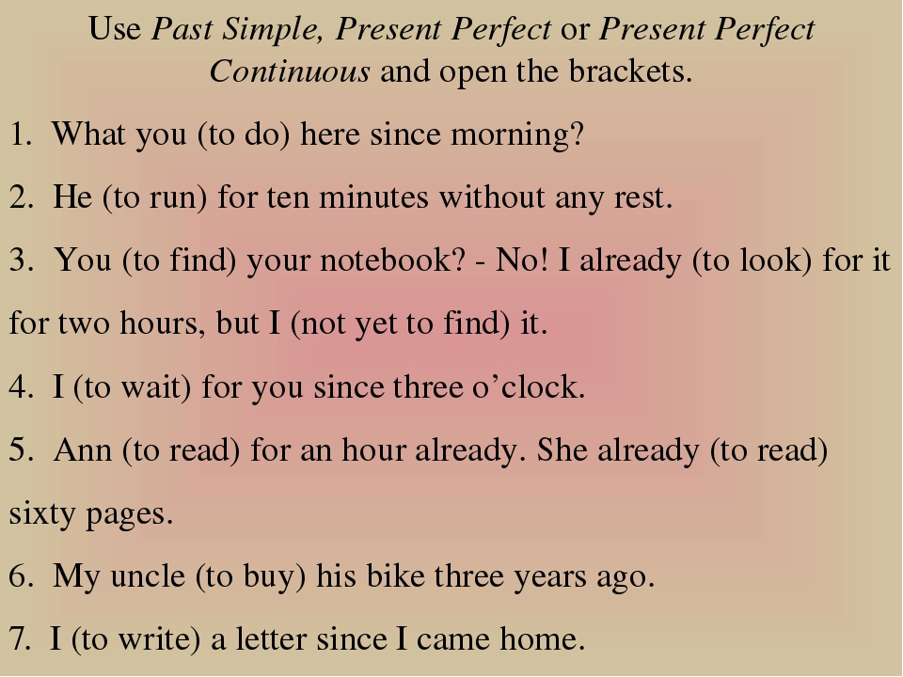

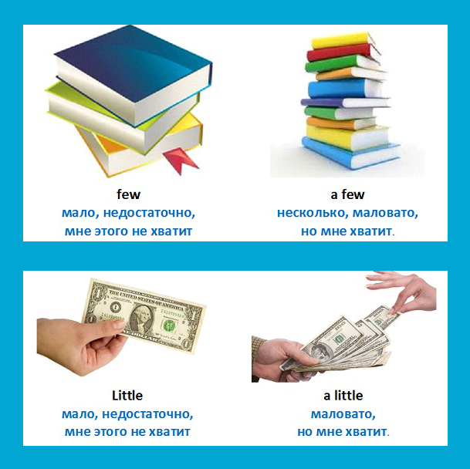

**Задание10**Вставьте few или a few

1. Susan has ________ friends. She doesn’t feel lonely.
2. You have _________ mistakes in the test. Correct them!
3. There are ________ puddles on the road. Let’s put on rubber boots.
4. _______ apples are enough for me not to feel hungry.
5. We will come back in __________ days.
6. The weather was bad, but ________people came.
7. I really need to see him. I've got …………… questions to ask him.

**Задание11**Вставьте *a few* or *a little.*

1. There are only _________ biscuits left.
2. There is ________ traffic here.
3. It’s winter, but we still have ________ flowers in the garden.
4. There were _________ taxis in front of the station.
5. Can I have_________ pepper, please?
6. She can give us_______ help.
7. Put ______ salt and mix the ingredients.
8. There are ______ bottles on the table.

**Задание12**

Вставьте few, a few, little, a little.

1. Would you like some beer? Just_______ please.
2. If you want to make pancakes, you need _______ eggs and _______ flour.
3. Would you like _______ more rice?
4. I bought _______ newspapers.
5. I'd like to drink _______ coffee.
6. This boy isn't very popular at school. He's got very _______ friends

**Задание13**

**.** Прочитайте текст и вставьте вместо каждого пропуска нужную грамматическую форму, выбрав её из выпадающего списка.

**The Dog and the Donkey**

Once in a small town there lived a baker. He had two pets – a dog and a donkey. The dog kept watch over the house. The donkey carried the bread and the cakes that the baker made.  
One night a thief A____ into the house. The baker B____ soundly. The dog too was fast asleep, he did not bark at the thief. The donkey saw the thief and wanted to awaken C____ master, so he began to bray loudly. The thief ran away.  
The baker could not sleep. He came out. He could not understand why the donkey brayed so loudly and he beat the stupid but dutiful donkey very badly. But the D____ house was saved. It was the duty of the dog to keep watch and not of the donkey. However, the donkey turned out to be a E____ guard than the dog.

**A** 1) broken 2) was breaking 3) broke 4) was broken  
**B** 1) sleeps 2) was sleeping 3) slept 4) has slept  
**C** 1) him 2) her 3) he 4) his  
**D** 1) baker 2) bakers’ 3) baker’s 4) bakers  
**E** 1) good 2) more good 3) best 4) better

**Задание14**

Reading task  
You are going to read the text about recycling. Your task is to choose the most suitable heading from the list A-I for each part (1-7) of the article. There is one extra heading which you do not need to use.  
  
A. Straw vs. paper  
B. Recycled plastic  
C. Reusing glass  
D. Recycling metal  
F. The process of recycling  
G. Recycling tin cans  
H. The importance of recycling  
I. Recycling paper  
  
  
RECYCLING  
  
(1) Recycling is a very important subject, and one that is becoming more so all the time. As we all know, it reduces waste and is good for the environment. But what do recycling centres do with the things we throw away? I found out some very interesting information.  
(2) Recycling paper has been the biggest success. In 1990, in the USA, more than 20 million tons of paper were recycled and turned into birthday cards, cereal boxes, and hundreds of other things. Paper is the easiest material to recycle and, as David Dougherty of Clean Washington said, "You can use it six times over, then burn what's left to create energy."  
(3) Wisconsin cow farmer George Plenty had the most interesting use for recycled paper: he uses it instead of straw in his barn. "It's cheaper than straw," he said, "but even if the price were the same, I wouldn't go back."  
(4) Plastic is the hardest material to recycle, because there are so many different kinds, all of which need to be treated differently. At the moment, only two per cent of the plastic used in the US is recycled. But is does have its uses: one company uses plastic from recycled car headlights to make windows. In some ways they are better than normal windows, because they are much harder to break. Another company, Image Carpets, uses plastic to make carpets and rugs. A comment made by the manager showed us how attitudes towards recycling have changed. "We worried that people might refuse to buy the carpets if they knew they were recycled," said sales Manager, John Richmeier. "Now we advertise the fact as a marketing strategy."  
(5) Metal is another important material. It is easier to recycle an aluminium can than to make a new one. It is also 20 per cent cheaper, and uses only 5 per cent of the energy that making a new can would use. So many of the things we use are made of metal, and can all be reused after they stop working. Recycling car parts, for example, is a big business. There is also very little waste involved in recycling metal. Steel is 100 per cent recyclable, and can be recycled hundreds of times. Recycling steel is cheaper than mining it. A lot of America's scrap metal is taken by the Japanese, recycled, and eventually sold back to America as new cars.  
(6) 20 per cent of America's glass is recycled, and used for a number of things. For example, it can be mixed with asphalt or cement and used to pave streets. It can also be melted down and used to make new bottles. However, unlike the other materials, glass can also be reused commercially in its original form; many types of bottles are returned to bottling plants, sterilized and refilled. Recycling and reusing glass is actually a huge worldwide business, with bottle banks appearing everywhere.  
(7) So remember, think before you throw things away — they may still be useful. If we all make an effort to recycle, we can make the planet a cleaner place to live.  
**Задание15**

**Text: “A Dolphin Asks For Help”**

A ship was fishing near the Kuril Islands when the men saw a dolphin in the water. It was swimming towards their ship. The dolphin’s movements were strange. When it was nearer the men could see that there was an open wound on the dolphin’s body. It tried to jump on the ship, but it couldn’t. The fishermen took the dolphin on the ship. The ship’s doctor said that this animal needed operation. During the operation, which lasted for an hour and a half, the men threw sea water over the dolphin. When the doctor had finished the operation, the men let the dolphin go back into the water. There were a lot of dolphins near the ship and they greeted it and swam round it as if they wanted to help it and to protect it.Then they all swam near the ship for a long time. This was the way they thanked the ship’s doctor and the fishermen for the help they had given to one of them

**Test**

“**A Dolphin Asks For Help”**

1. The dolphin’s movements were …
2. strange;
3. usual;
4. quick.
5. The men could see that …
6. the dolphin was very tired;
7. the dolphin was catching fish;
8. there was an open wound on the dolphin’s body.
9. The dolphin tried …
10. to swim away from the ship;
11. to jump on the ship;
12. to catch a big fish.
13. The ship’s doctor said that the animal needed …
14. operation;
15. rest;
16. sleep.